**What is Tableau Group?**

A **Tableau Group** is a set of multiple members combined in a single dimension to create a higher category of the dimension. Tableau allows the grouping of single-dimensional members and automatically creates a new dimension adding the group at the end of the name. Tableau does not do anything with the original dimension of the members.

In this tutorial, you will learn-

* [Sort data](https://www.guru99.com/tableau-sort-data.html#1)
* [Create Groups](https://www.guru99.com/tableau-sort-data.html#2)
* [Create Hierarchy](https://www.guru99.com/tableau-sort-data.html#3)
* [Create Sets](https://www.guru99.com/tableau-sort-data.html#4)

**Sort data:**

Data present in the visualization and worksheet can be sort based on the requirement. It can sort the data based on data source order, ascending, descending or depend on any measured value.

The procedure for sorting is given as follows.

**Step 1)** Go to a Worksheet and drag a dimension and measure as given in the image.

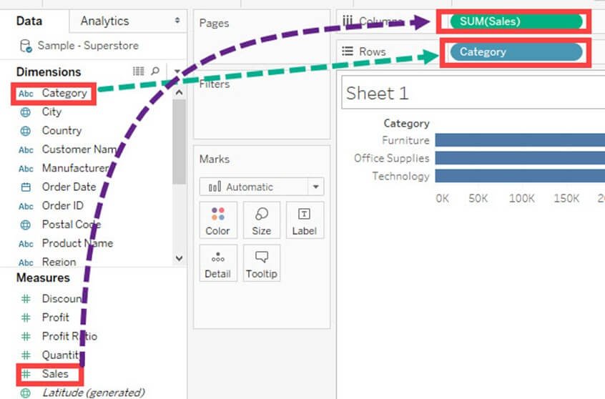

It creates a bar chart by default. Category Present in the visual is sorted based on data source order by default. We can change the sort order by following the below procedure.

**Step 2)**

1. Right click on Category.
2. Select ‘Sort’ option.

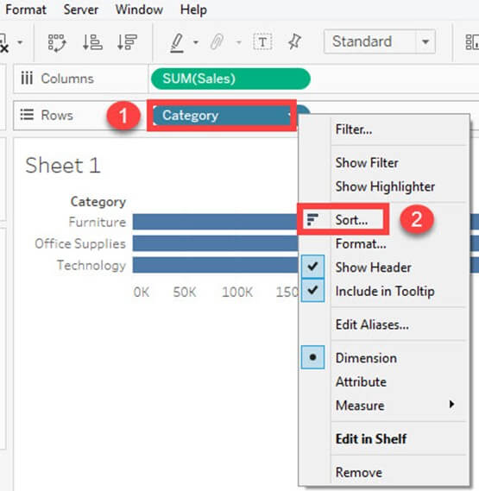

It opens the Sort window. The options present inside the sort window is explained as follows.

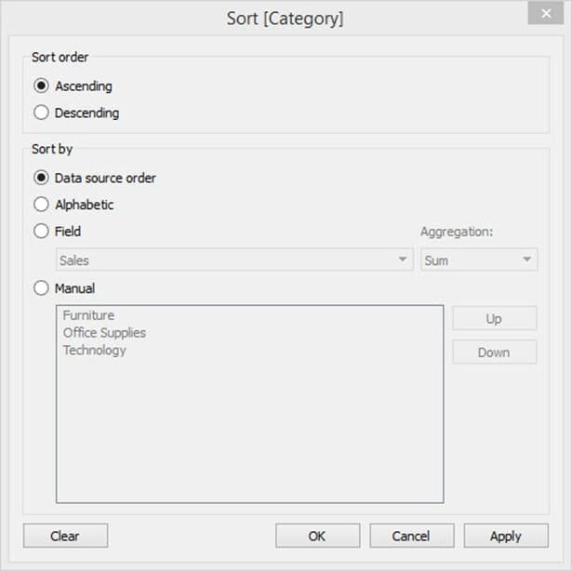

**Sort Order:**

* Ascending: It sorts the order of selected dimension in ascending order.
* Descending: It sorts the order of selected dimension in descending order.

**Sort by:**

The field can be sorted by different types of methods. It is explained as follows.

|  |  |
| --- | --- |
| **Data Source order** | It sorts the field based on data source order. |
| **Alphabetic** | It sorts the field based on the alphabetic order. |
| **Field** | It sorts the field based on other dimension or measure values. |
| **Manual** | The user can manually sort the data using this option. |

In this example, the category is sorted based on another field namely ‘Sales.’

**Step 1:**In this window,

1. Click on ‘Field’ radio button.
2. Select the field on which the category is to be filtered.
3. Select the aggregation type.
4. Click on OK.

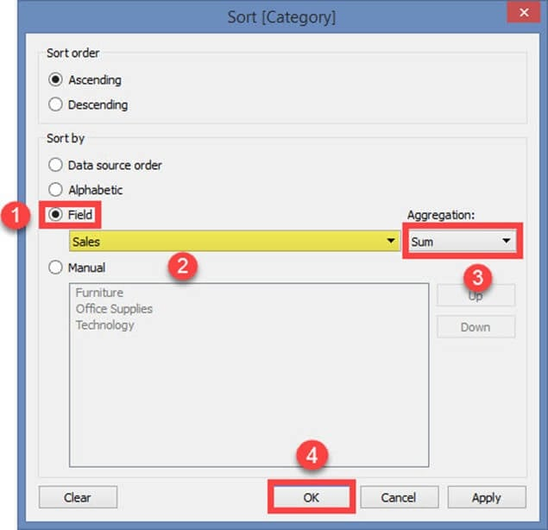

The above example filters the category field based on the sum of sales in ascending order.

It sorts the data as shown in the figure.

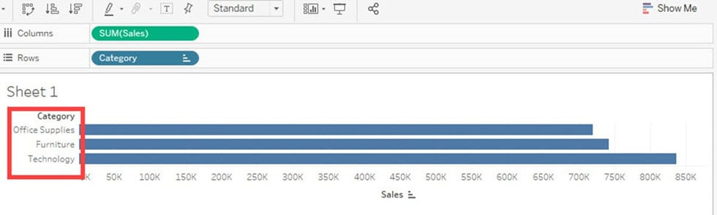

## Create Groups:

Group is used to combine members present in a field. For example, aggregated values of ‘Furniture’ and ‘Office Supplies’ can be obtained by using group. Once the grouping data in Tableau is done, aggregated value of ‘Furniture’ and ‘Office Supplies’ can be shown in the visuals. The procedure to Group Data in Tableau is given as follows.

**Step 1)**

1. Right-click on the dimension ‘Category’.
2. Click on ‘Create’ option.
3. Select ‘Group’ option.

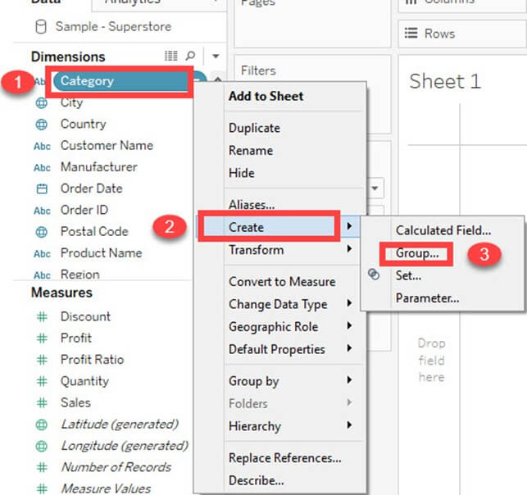

**Step 2)** It opens the ‘Create group’ window.

1. Type the name of the group data in Tableau.
2. Select the members to be grouped.
3. Click on ‘Group ‘button.

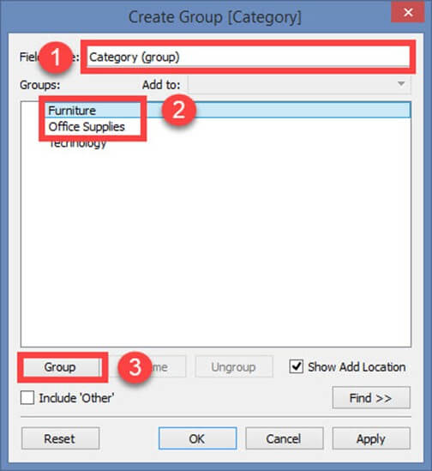

**Step 3)** In Edit Group Window,

1. It creates groups in Tableau of ‘Furniture’ and ‘Office supplies’.

2. Click on Ok to create the group.

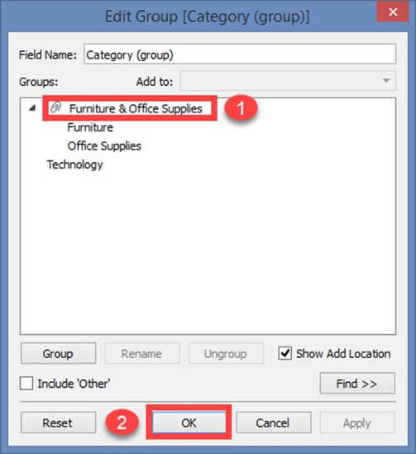

It created a group in Tableau with the name of Category (Group) and added in the dimension list. This can be used for visualizing the group by in Tableau method for members present in a field.

The following image explains the functionality of Tableau create group. The sum of sales is visualized for both furniture and office supplies for grouping in Tableau.

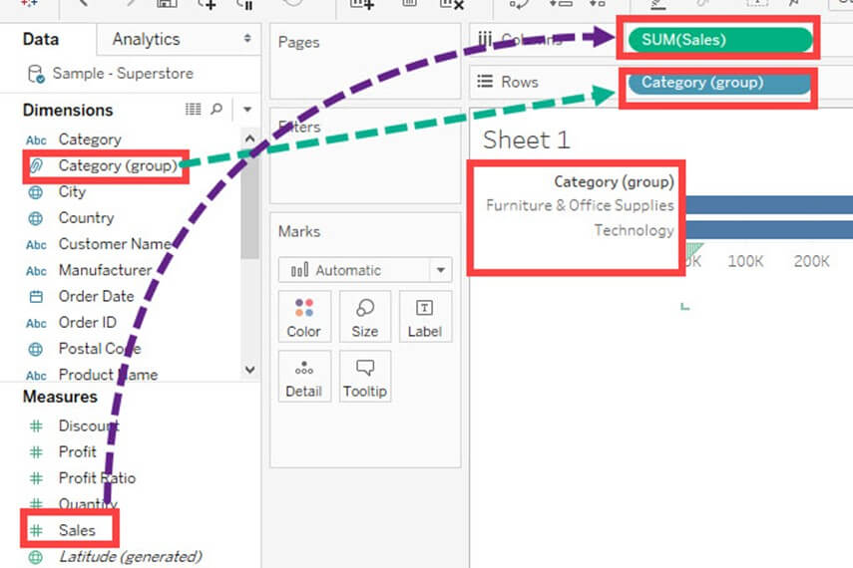

## Create Hierarchy:

Hierarchies can be building in Tableau to visualize the data in granular level. Tableau hierarchies can be created by following the given steps.

**Step 1)** Go to a worksheet.

1. Select a dimension to create a hierarchy. Right-click on the dimension.
2. Select ‘Hierarchy’ option.
3. Click on ‘Create hierarchy’ option.

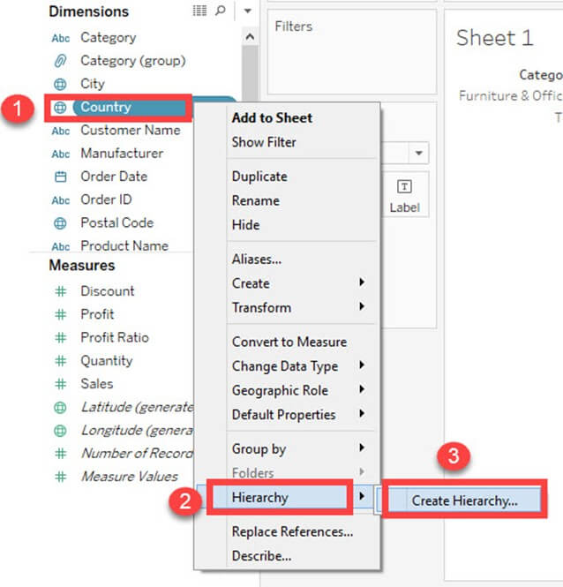

**Step 2)** It opens the ‘Create Hierarchy’ Window.

1. Enter a name for hierarchy.
2. Click on OK.

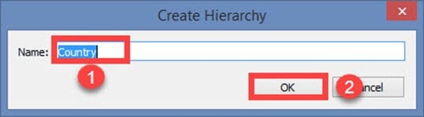

It creates a Hierarchy as shown in the image.

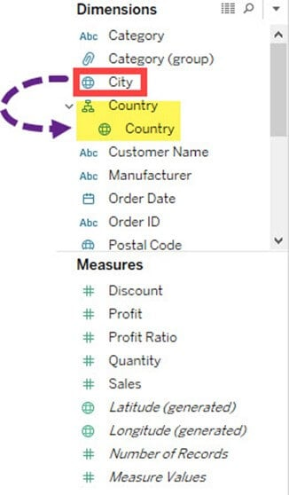

You can add another field to the box and create the hierarchy. In this example, the city is added into a country hierarchy.

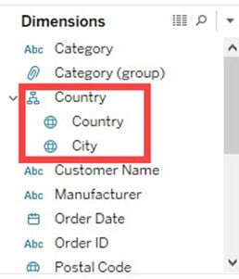

## Build Sets:

Sets create a set of members out of the field present in a data set. It acts as a separated field or dimension. The procedure to build sets is given as follows.

**Step 1)** Go to a Worksheet.

1. Right-click on a dimension.
2. Select ‘Create’ option.
3. Click on ‘Set’ option.

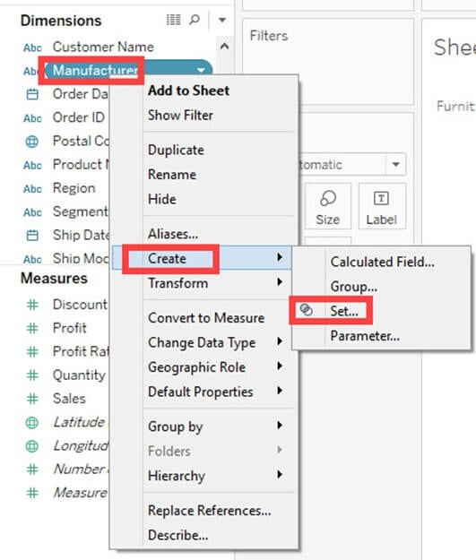

**Step 2)** It opens ‘Create Set’ Window.

1. Name the set to be created.
2. Select the members needs to be added in the set.
3. Click on OK.

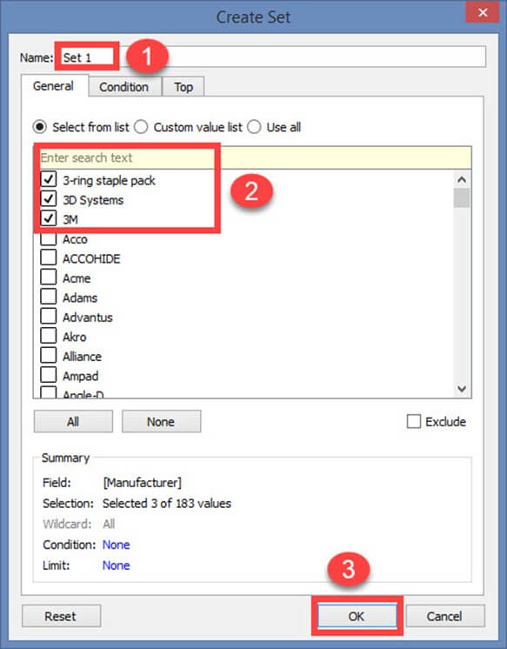

This creates a set of the given name.

## Summary:

* Users can sort the fields present in the data set.
* Tableau groups can be built to group the members present in a dimension.
* Users can build hierarchy to show the granularity level present in the dataset.
* Sets can be created to select or exclude one or more members from a field. A set can be added as a separate dimension in Tableau.

# Tableau Maps:

Tableau’s geo-mapping capability allows users to plot the geographical data and create visualizations. Users can create interactive maps in Tableau based on their requirements. This Tableau maps tutorial explains the procedure for constructing various types of maps.

## Plotting Shapes on Maps

Users can plot shapes on the maps based on the geographical details available in the data set. Plotting shapes on maps can be used to mark the geographical location. It marks the center point of any location details in the data source.

This method of plotting shapes should be used in both Tableau-generated location details and customized location details (available in the location data set). The size and color of shapes that describe geography’s location should be modified to the measurement values of the specific location.

This tableau map example gives the procedure for plotting different types of shapes.

**Step 1)**Go to a new worksheet.

1. Drag ‘State’ into the Detail icon present in the Marks card.

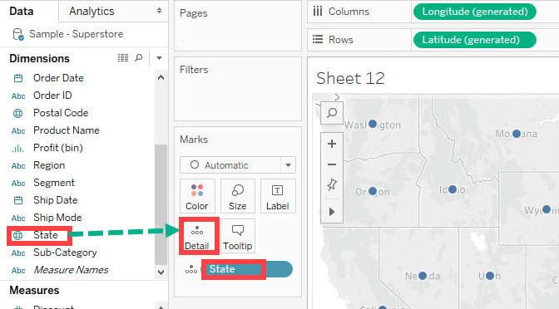

It creates a Map using the geographical location of the state. By default, [Tableau](https://www.guru99.com/tableau-tutorial.html) shows a dot-shaped structure to plot the location. It can be changed by following the given steps.

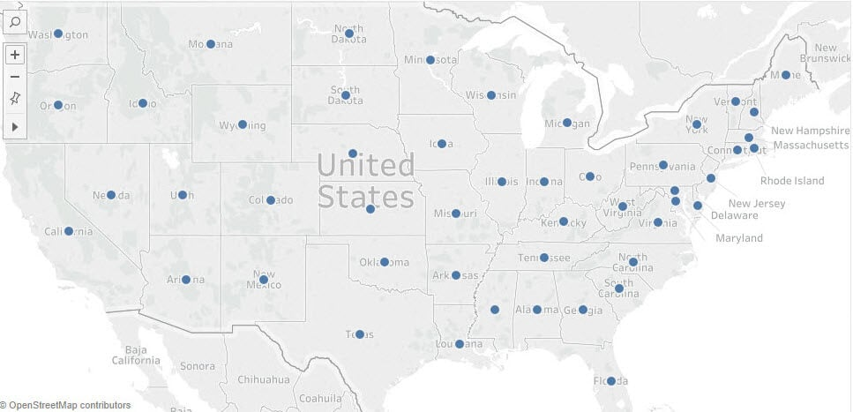

**Step 2)**In the next screen,

1. Go to Mark’s card.
2. Click on the dropdown button, as shown in the image.
3. Select the ‘Shape’ icon present in the list.

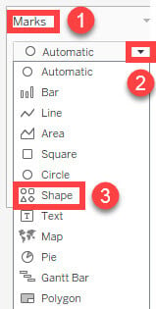

**Step 3)**In the next screen,

1. Click on the Shape icon present in the Marks card.
2. Select the star shape from the list.

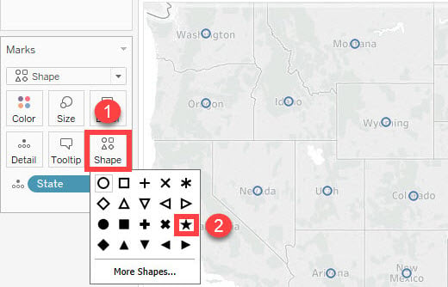

**Step 4)**In the next screen,

1. Click on the Size icon present in the Mark’s card.
2. It shows a slider to increase or decrease the size of the plots. You can drag the slider to the right side to increase the size of the star-shaped plot.

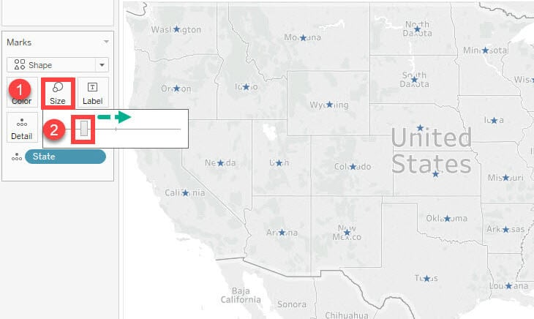

It creates a map with the locations plotted using the star-shaped structure.

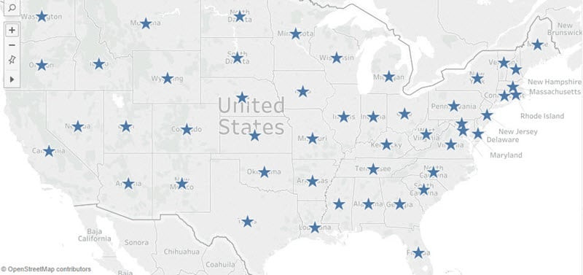

**Tableau Symbol Maps Data Visualizations**

Tableau Symbol maps are similar to plotting shapes on point distribution maps. The location of maps can be represented as a symbol, which also denotes the status of key performance indicators in various locations. It can be used to show the location and details of measures.

It can create interactive tableau map visualizations, as symbols represent the increase or decrease in key performance indicators.

For example, if you want to know about the increase or decrease in profit in different locations, you can use the proportional symbol maps. The procedure to create a Tableau mapping symbol is given as follows.

**Step 1)**Go to a new Worksheet.

1. Right-click on the ‘Profit’ present in the Measures pane.
2. Select ‘Create’ from the list.
3. Click on ‘Calculated Field’ from the sub-list.

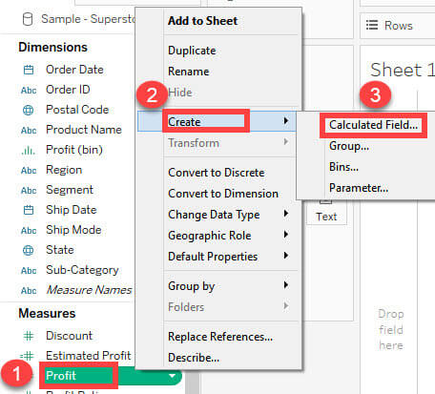

**Step 2)**It opens a Calculated Field Window.

1. Enter the name as ‘Profit Flag’.
2. Then write the formula to show a positive or negative profit as given in the image.
3. Click on the OK button.

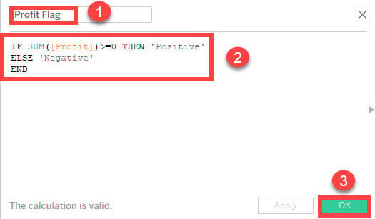

**Step 3)**Drag the newly created calculated field, namely ‘Profit Flag’, into the Shape icon in the Marks card.

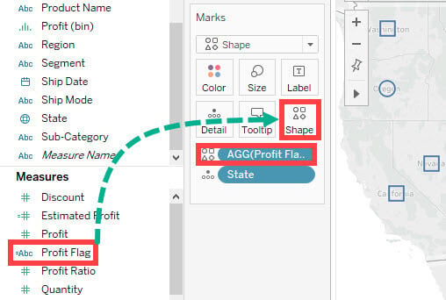

**Step 4)**In the next window,

1. Click on the Shape icon present on Marks’s card.
2. It opens the ‘Edit Shape’ Window.
3. Click on the drop-down button present in ‘Select shape Palette’.
4. Select the shape from ‘Thin Arrows’ present on the list.

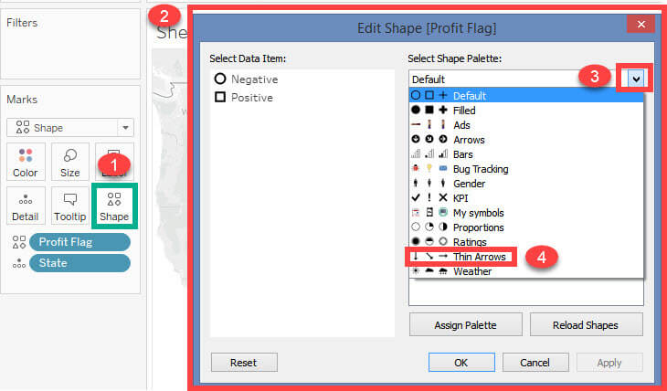

**Step 5)**Now in the next screen,

1. Click on the ‘Negative’ member present on the left side of the window.
2. Now click on the down arrow shape present in the palette. This assigns the down arrow shape into ‘Negative’.

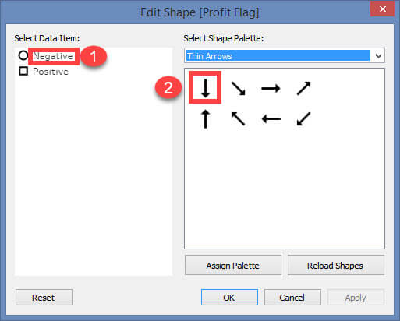

**Step 6)**Next,

1. Click on the ‘Positive’ member present on the left side of the window.
2. Now click on the up-arrow shape present in the palette. This makes an up-arrow shape to ‘Positive’.
3. Click on OK.

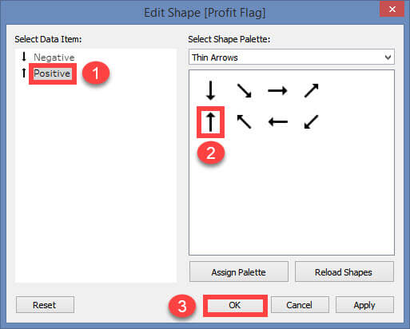

**Step 7)**In this screen,

1. Go to the Marks card and click on the size icon.
2. Drag the slider to the right side to increase the size of symbols present in the map.

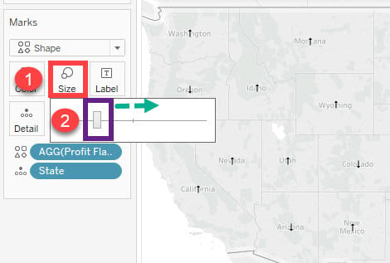

It creates a symbol map. The symbols represent the location of geography and the increase or decrease in profits.

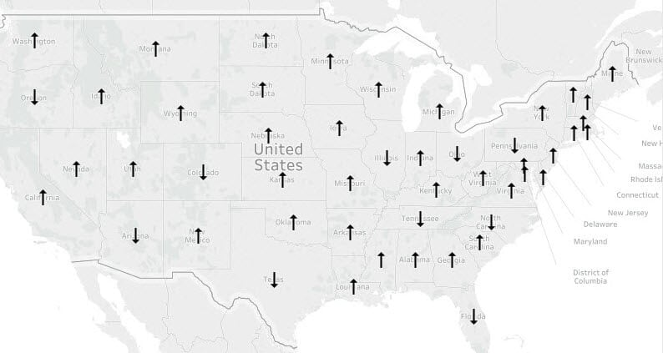

**Tableau Filled Maps with Example**

Filled maps show the entire region of the geography present in the data set. In the above chart types, the geography location is denoted using a shape in the middle of the geography. But in filled maps, the whole region is covered to show the entire map.

Complete-filled maps include data points of the whole region of the geography. It covers the entire territory of geography using a polygon. Thus, interactive and highly defined visualizations can be created using the filled maps option in Tableau.

The procedure for creating filled maps in Tableau is shown below.

**Step 1)**Go to a new Worksheet.

1. Hold the control key and click on ‘State’ and ‘Sales’ present in the data pane.

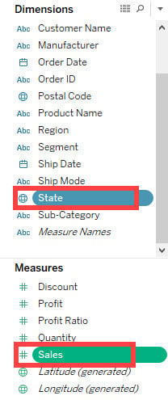

**Step 2)**In the next window,

1. Click on the ‘Show Me’ option present in the top right corner of the worksheet.
2. Select the ‘Filled Map’ icon in the list, as shown in the image.

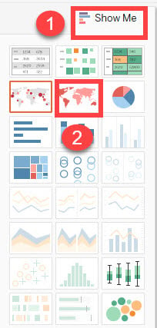

It creates a filled map, as shown below. The map’s color shows the sales of that particular USA state. The darker the color of the specific state, the larger the sales number, and vice versa.

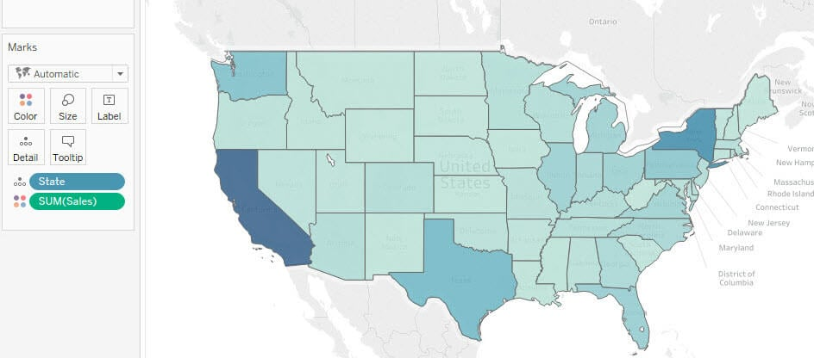

**Editing Location using Tableau Mapping**

You can see that in the above examples, the map was created by longitude and latitude coordinates generated in Tableau.

Depending upon its geography name, the location information is automatically generated in Tableau.

**Note**: Sometimes, you must edit the location to show the map based on its latitude and longitude details.

Here are steps to edit the location in Maps:

**Step 1)**Import the dataset “house_Prices.csv” into Tableau.

**Note:** This data set consists of location details of houses in the USA. In the data set, ‘Id’ is the primary key. The latitude and longitude can be plotted for each id to show the location of all houses.

**Step 2)**Go to a Worksheet.

1. Right, click on ‘Long’ present in the measures pane.
2. Select the ‘Geographic Role’ present on the list.
3. Click on the ‘Longitude’ option available in the data set. This step is used to allocate the geographic role to the selected column.

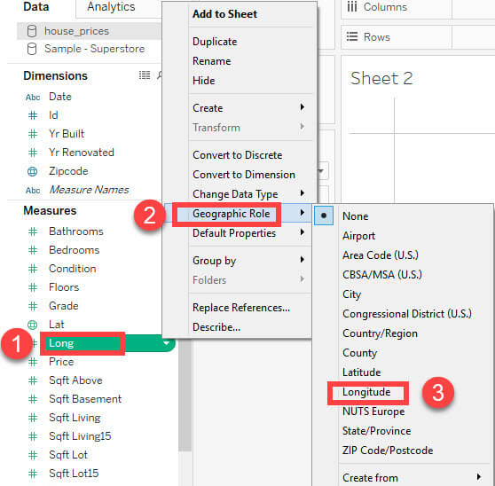

**Step 3)**In the next window,

1. Drag ‘Long’ into Columns.
2. Drag ‘Lat’ into Rows.
3. Drag ‘Id’ into the detail icon present in the Marks card.

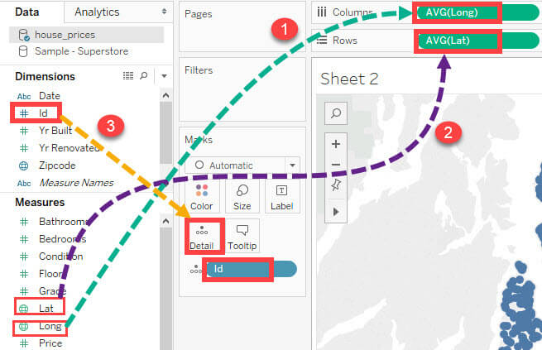

**Step 4)** It creates a Map based on the given latitude and longitude details, as shown below. It shows each house present in the data set.

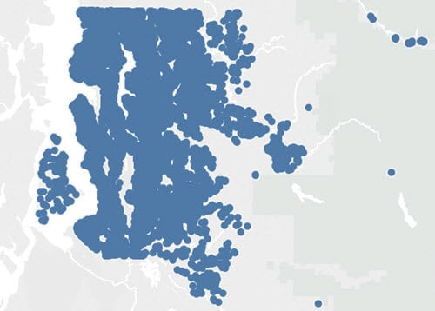

**Tableau Dashboard**

A dashboard is a consolidated display of many worksheets and related information in a single place. It is used to compare and monitor a variety of data simultaneously. The different data views are displayed all at once. Dashboards are shown as tabs at the bottom of the workbook and they usually get updated with the most recent data from the data source. While creating a dashboard, you can add views from any worksheet in the workbook along with many supporting objects such as text areas, web pages, and images.

Each view you add to the dashboard is connected to its corresponding worksheet. So when you modify the worksheet, the dashboard is updated and when you modify the view in the dashboard, the worksheet is updated.

Creating a Dashboard

Using the Sample-superstore, plan to create a dashboard showing the sales and profits for different segments and Sub-Category of products across all the states. To achieve this objective, following are the steps.

**Step 1** − Create a blank worksheet by using the add worksheet icon located at the bottom of the workbook. Drag the dimension Segment to the columns shelf and the dimension Sub-Category to the Rows Shelf. Drag and drop the measure Sales to the Color shelf and the measure Profit to the Size shelf. This worksheet is referred as the Master worksheet. Right-click and rename this worksheet as **Sales_Profits**. The following chart appears.

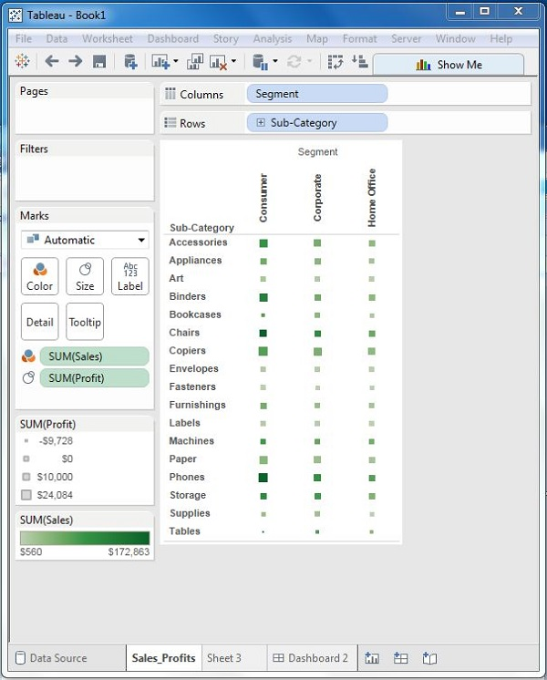

**Step 2** − Create another sheet to hold the details of the Sales across the States. For this, drag the dimension State to the Rows shelf and the measure Sales to the Columns shelf as shown in the following screenshot. Next, apply a filter to the State field to arrange the Sales in a descending order. Right-click and rename this worksheet as **Sales_state**.

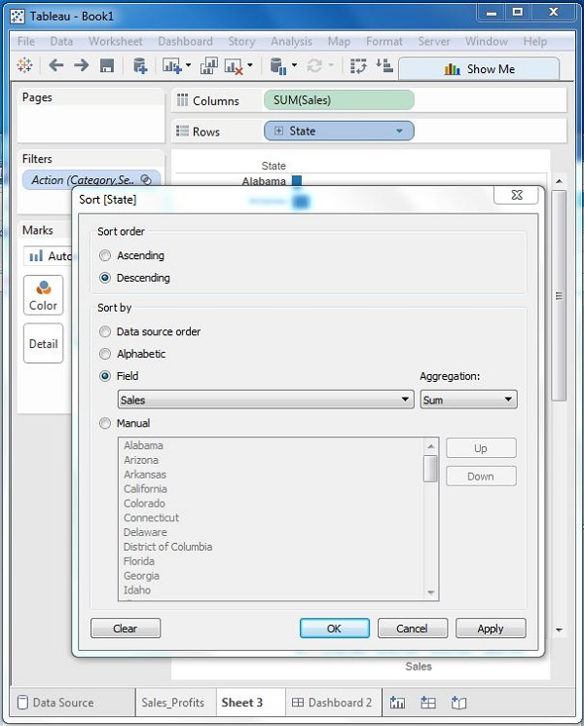

**Step 3** − Next, create a blank dashboard by clicking the Create New Dashboard link at the bottom of the workbook. Right-click and rename the dashboard as Profit_Dashboard.

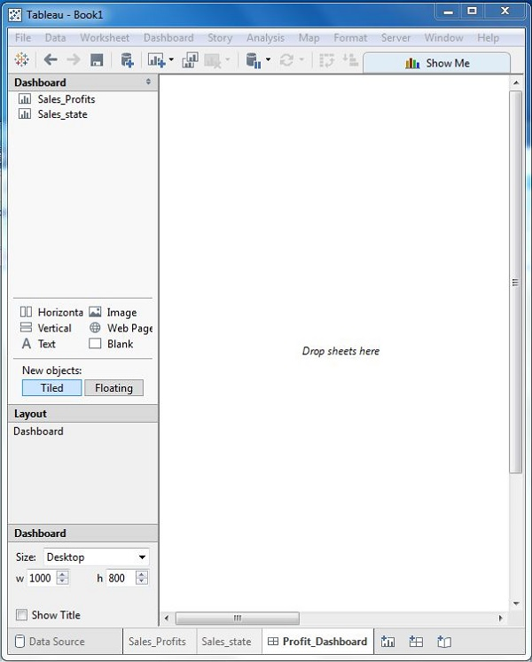

**Step 4** − Drag the two worksheets to the dashboard. Near the top border line of Sales Profit worksheet, you can see three small icons. Click the middle one, which shows the prompt Use as Filter on hovering the mouse over it.

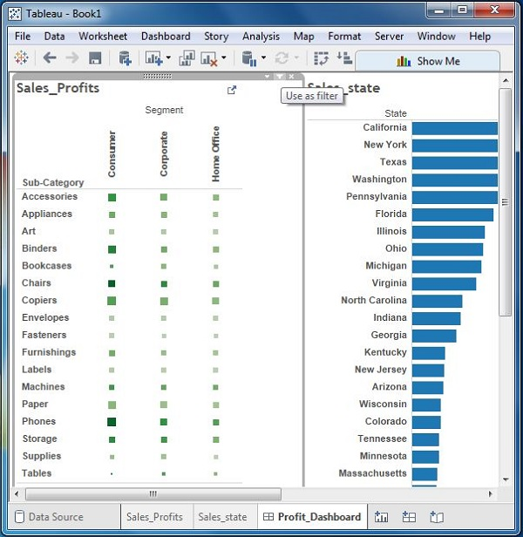

**Step 5** − Now in the dashboard, click the box representing Sub-Category named Machines and segment named Consumer.

You can notice that only the states where the sales happened for this amount of profit are filtered out in the right pane named **Sales_state**. This illustrates how the sheets are linked in a dashboard.

